Identification of an Unknown- A
McCall Rader
November 27th, 2023
Chem 2081-001

Introduction
In lab, spectroscopy can be used to identify different things. Spectroscopy can be used for analytical and physical chemistry which helps determine the molecular sample. To identify an unknown compound using mass spectroscopy the molecular formula, empirical formula, and functional groups need to be determined. When using mass spectrometry to find the unknown compound it can describe properties of the compound like protons, ions, molecules, etc. Being able to read spectroscopy determines the structures of atoms and the bonds present in the given molecules.
Body
Spectroscopy is the study of the absorption and emission of light based on matter. It uses electromagnetic radiation and splits the light into its wavelengths. This causes a spectrum to be formed and a rainbow of colors. Particles interact with one another and with other particles in relation to the energy of their collisions, including electrons, protons, and ions. There are three analytical methods for analysis which are NMR, FTIR, and MS.
NMR stands for Nuclear Magnetic Resonance. The instrument allows the molecular structure of the compound to be analyzed by the interaction of nuclear spins in a magnetic field. This can include to help determine the physical, chemical, and biological properties. Its overall purpose is to identify organic structures and protons.
Another method is the FTIR, which stands for Fourier Transform Infrared Spectroscopy. FTIR identifies the presence or absence of functional groups. The FTIR analysis method scans test materials and examines chemical characteristics using infrared light. The infrared energy is passed through an organic sample and absorption bands are formed and observed. An absorption band is called a peak on the graph. The intensity of absorption or transmittance is on the y-axis. The wavelength or frequency is plotted on the x-axis.
The last method is Mass Spectroscopy or MS. Mass Spectrometry measures the m/z of the molecules or ions in the sample. This can determine the molecular weight, structure, and characteristics of the particles. It works but a compound being introduced into the MS and turned into a gas-phase ion. Then then ion is sorted by their mass to charge ratio or m/z. Lastly, an electric current is generated by the number of ions of the m/z value. The ions are typically a +1 charge. The x-axis of the graph represents the molecular weight with unit m/z. The y-axis is usually labeled relative abundance, and this shows ratios in the sample (CHEM 2081 Organic Chemistry 2 Lab Manual).

Data
NMR:
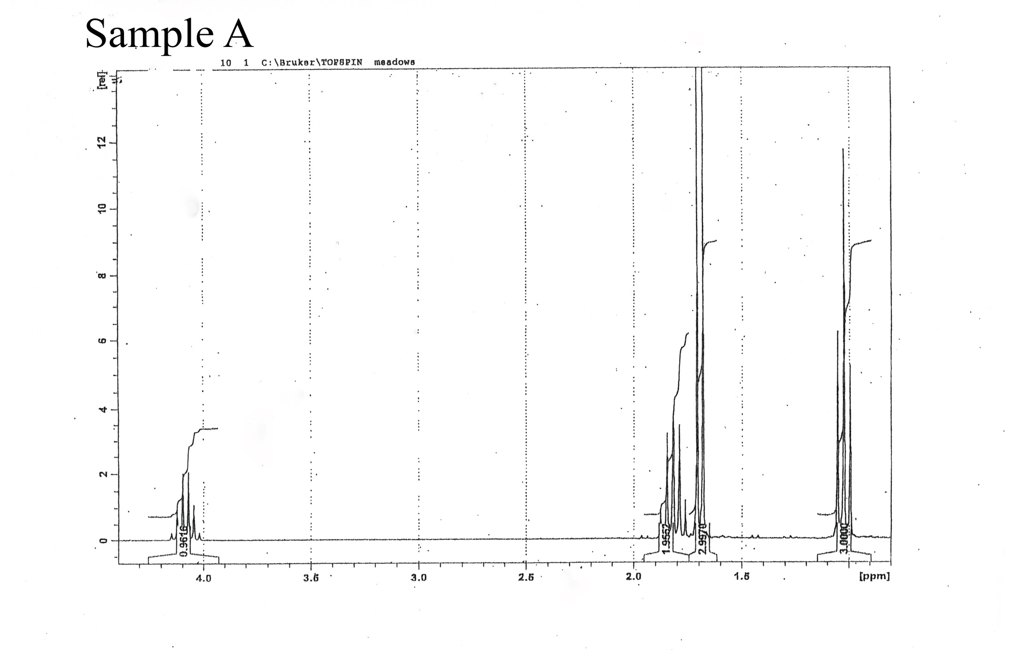
FTIR:
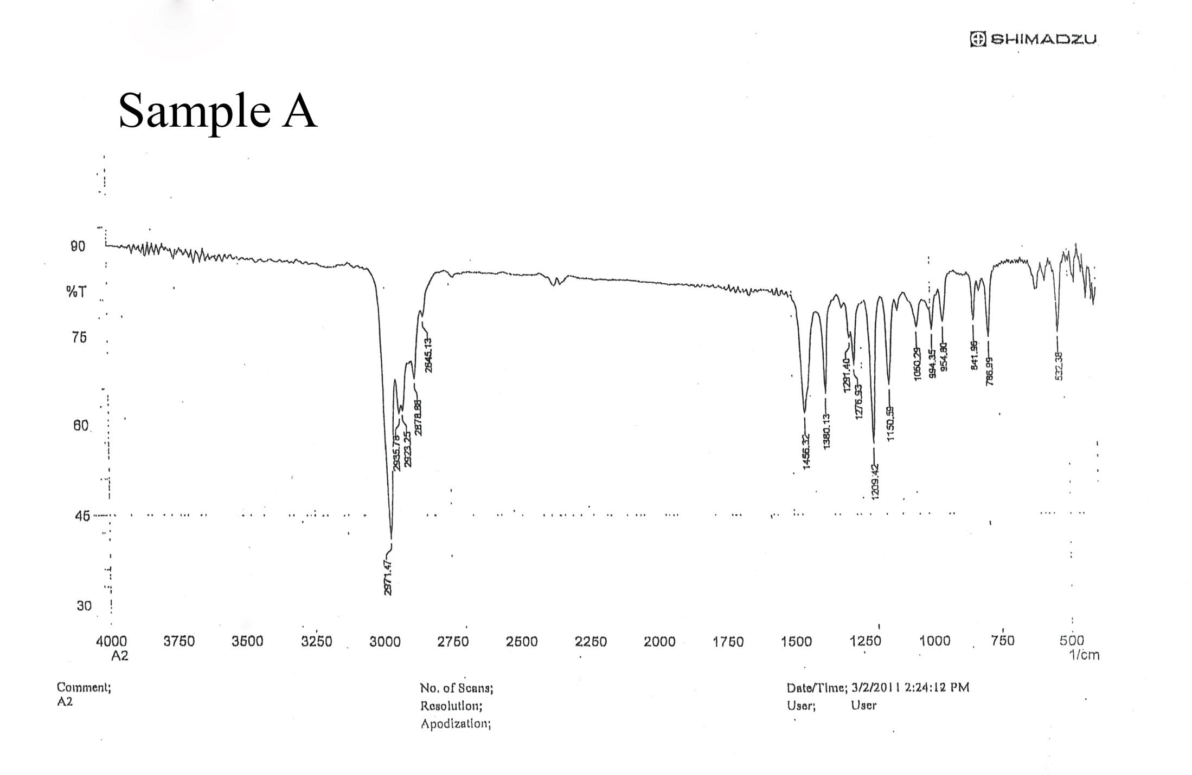

GCMS or MS:
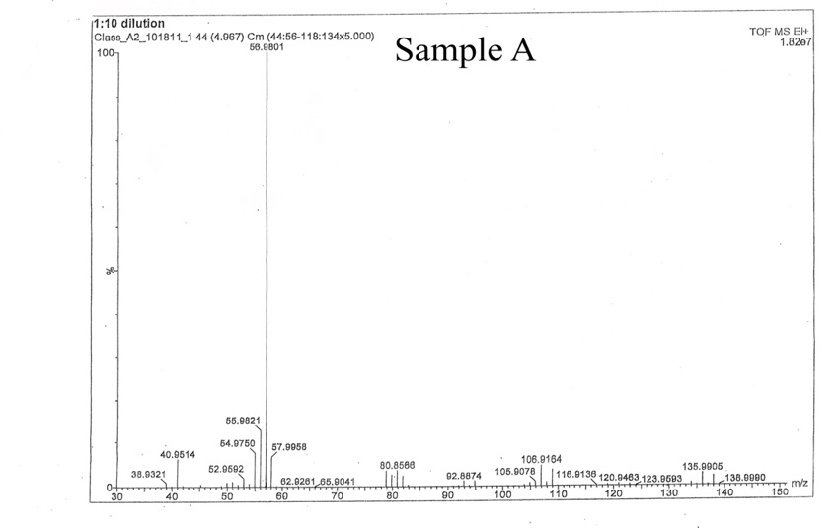
Analysis
The NMR is in the range of 1.9 to 1.65, the peak 1.9552 is a narrow peak. This means it is a carbonyl or C=O. In the range of 1.75 to 1.6, the peak 2.9970 is a narrow peak, C=O. In the range 1.15, the peak 3.000 is a narrow peak, is in the fingerprint region, which means it’s not in the functional group range. For the peak around 3.9 to 4.25 which is 0.9616. It is the closest to N-H since it stops at 3.5. This is the closest peak.
For FTIR, all the peaks to the right of 1500 are in the fingerprint region, which means that they are corresponding to a functional group. To the left of 1500, the range is from 2750 to 3000, which is the range of an acid O-H, which is close to the C-H group as well. The FTIR is hard to read as there isn’t as much useful information to help identify the unknown.
In the MS, 38.9990 m/z is the highest mass spectroscopy, which is the relative molecular mass. When looking at the peaks that need to be used, those would result in the highest peak. For the unknown, Br equals 135.9905 m/z. Then for the other part to identifying the unknown is the M+= highest peak, 56.9801.
Conclusion
In conclusion, the three methods used were Nuclear Magnetic Resonance, Fourier Transform Infrared Spectroscopy, and Mass Spectroscopy. While reading this analysis, Mass Spectroscopy was found to be the most helpful in identifying the unknown. The highest peak was identified as 56.9801 m/z and the Br equals 135.9905 m/z. With this given information from the MS graph, C4H9Br is the structure. The unknown is 2-Bromobutane as seen below.
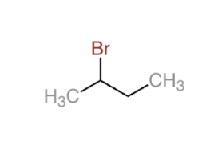
2-bromobutane

References
Keller L, Joseph K, and Miguel S. 2022 Fall. CHEM 2071 Organic Chemistry 1 Lab Manual [lab manual]. Auburn (Al): Auburn University.

